Hypothesis 3 - Peri-contact Reorientation
Do animals reorient their body axis toward the ethanol source upon an encounter?

1. Goal and Hypotheses
H3 predicts that following an ethanol encounter the body axis turns TOWARD the source, so the absolute body-axis angle to the source, |theta|, DECREASES from the pre-contact window to the post-contact window (reorientation).
H3 (alternative): post-contact |theta| < pre-contact |theta| (reorientation toward source).
H0 (null): |theta| is unchanged across the contact (pre = post).
Acceptance rule: accept H3 only if the trial-level paired test shows post |theta| significantly below pre |theta|. Direction is reported before significance.

2. Methods
Data were read through the shared accessor and geometry library traj_common (version traj_common/1.0) against the aggregate file C:\Projects\Repos\Mouse Arena\DATA\Mouse Arena Aggregate Data.h5. All processing used the fixed interpreter at 'C:/Projects/Repos/Agentic Research/Research Setup/vras/Scripts/python.exe' with random seed 1234.
Encounter (contact) onsets were detected on the head-clock-aligned ethdeconv trace using the calibrated threshold detector (k = 5 times MAD of the quiet, far-from-source baseline), with encounter time defined as the upward-crossing onset on the head clock.
Noise-floor caveat (honest interpretation of what the encounter onsets index): the calibrated encounter threshold sits at the deconvolved NOISE FLOOR, so the ~28 onsets per trial (7,814 pooled contacts) index low-amplitude noise / exposure crossings, NOT discrete high-amplitude odor contacts. Concretely, the calibrated threshold (7.18e-04 on ethdeconv) is the same order of magnitude as the pooled per-trial noise floor (median per-trial ethd ~4.34e-04) and as the median ethdeconv AT detected onsets (7.45e-04), while a real odor signal reaches ~0.14. Only a fraction 2.6e-04 of onsets (~0%) exceed the physically meaningful 0.01 amplitude, and at a secondary 0.01 amplitude threshold the per-trial encounter counts collapse to ~0 (median; max = 5), i.e. discrete high-amplitude odor contacts are essentially absent. The peri-contact analysis is therefore triggered on noise-floor events, which is fully consistent with the observed NULL (no reorientation): there is no discrete odor contact for the animal to reorient to. Threshold selection note: smallest-k rule returns the most permissive threshold on this degenerate (near-silent) quiet baseline; harmless here because all encounter-dependent results are null, but should not be used to support a positive claim.
Peri-contact sampling (D10): for each encounter onset, |theta| was sampled on a -1.0 s to +1.0 s window around onset on a 50 ms fixed grid on the head clock. The pre window is [-1.0, 0) s and the post window is (0, +1.0] s. Contacts whose window ran past the track ends contributed only their in-range samples.
Inferential test (replication unit = trial): for each trial with at least one encounter, the mean |theta| in the pre window and in the post window were computed; a paired Wilcoxon signed-rank test across trials evaluated the one-sided alternative that post < pre. The pooled peri-contact mean-|theta| curve (F4) is descriptive, with a 95% confidence band from bootstrap over trials (n_boot = 2000, seed = 1234).
Pooling: all encounters across Loc1-6 were pooled; the paired test used n = 105 trials (unit = trial).

3. Results
H3 is NOT supported. The direction of the effect is opposite to (or negligibly different from) the prediction: the pooled peri-contact curve is essentially flat around t = 0, with no reorientation toward the source.
Direction (reported first): median pre-contact |theta| = 70.01 degrees versus median post-contact |theta| = 69.66 degrees (change of -0.34 degrees). The two medians are essentially equal - post |theta| is unchanged, NOT reduced. Across the 105 trial pairs the majority direction is post > pre (64 pairs with post > pre versus 41 pairs with post < pre), i.e. if anything |theta| is slightly larger after contact. This is the opposite of the predicted decrease; no reorientation toward the source is observed.
Significance: the paired Wilcoxon signed-rank test of the one-sided alternative 'less' (post < pre) across n = 105 trials gave W = 3710.0, p = 0.9985. The large p-value indicates post |theta| is NOT below pre |theta|; the null of no reorientation cannot be rejected in the predicted direction.
Sample sizes: 7,814 contacts were pooled across 105 trials contributing to the peri-contact curve; 105 trials had at least one encounter and entered the paired test. (descriptive_only flag = False.)
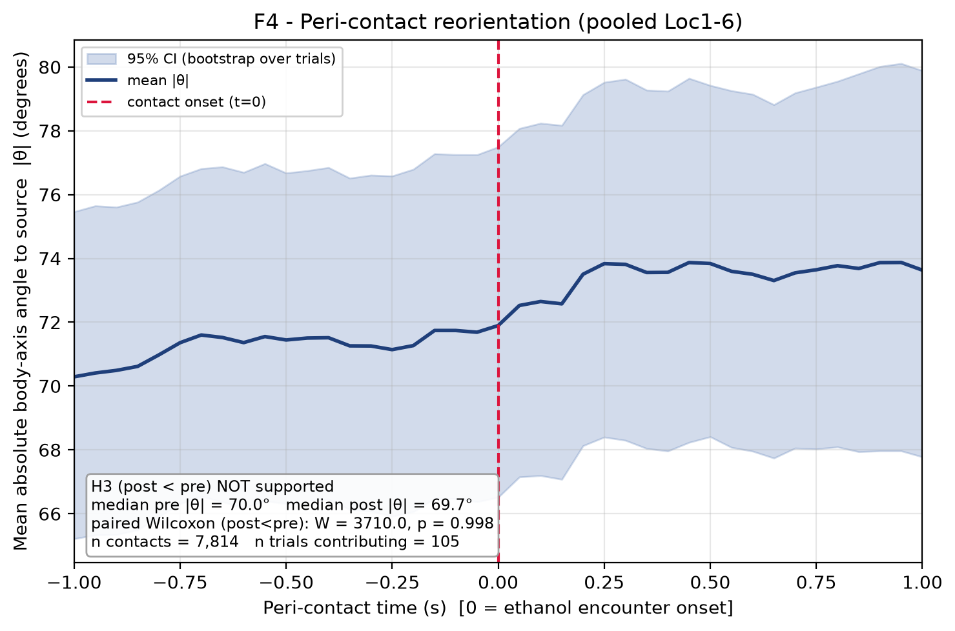
Figure F4. Peri-contact reorientation, pooled over all encounters across Loc1-6. x = peri-contact time (-1.0 to +1.0 s, 50 ms grid); y = mean absolute body-axis angle to source |theta| (degrees). Line = mean; shaded band = 95% CI (bootstrap over trials, seed 1234). Dashed vertical line marks contact onset (t = 0). n contacts = 7,814; n trials contributing = 105. Paired Wilcoxon (post<pre): W = 3710.0, p = 0.9985; median pre |theta| = 70.0 deg, median post |theta| = 69.7 deg. The curve is flat/slightly rising across t = 0: no reorientation toward the source.

3.1 Key numbers
Quantity | Value
Median pre-contact |theta| (deg) | 70.0056
Median post-contact |theta| (deg) | 69.6613
Change post - pre (deg) | -0.3444
Paired Wilcoxon statistic W (post<pre) | 3710.0
Paired Wilcoxon p (one-sided, post<pre) | 0.998487
Direction | post>pre
n contacts (pooled) | 7,814
n trials contributing to curve | 105
n trials with >=1 encounter (paired) | 105
H3 supported? | No (null result)

4. Caveats
Angle convention verified: |theta| is the absolute angle between the body axis and the vector to the source, computed in traj_common; smaller |theta| means better alignment toward the source, so the H3 prediction is unambiguously a DECREASE.
Contacts may be exposure-driven rather than discrete biological reorientation events. Encounter onsets are threshold crossings on a deconvolved ethanol signal; a large count of contacts pooled from many trials does not guarantee that each is a distinct, behaviorally salient stimulus, so the flat peri-contact curve may reflect exposure structure rather than an absence of any fast reorientation reflex.
Single cohort, infrared imaging, pixel units: results come from one cohort recorded under infrared, with distances and geometry in pixels; generalization is limited.
Direction before significance: the effect direction (post approximately equal to / slightly above pre) is reported first and is itself inconsistent with H3, independent of the (non-significant) p-value.

5. Reproducibility
All numbers above were injected directly from the saved result object:
Stats: C:\Projects\Repos\Mouse Arena\Analysis\trajectories\data\stats.json
Figure: C:\Projects\Repos\Mouse Arena\Analysis\trajectories\reports\figures\F4_peri_contact_angle.png (+ .pdf, + .txt sidecar)
Metrics: C:\Projects\Repos\Mouse Arena\Analysis\trajectories\data\trajectory_metrics.h5 / .json
Seed = 1234; traj_common traj_common/1.0; stats.json created 2026-08-08T04:40:54Z.
Exact reproduce command:
"C:/Projects/Repos/Agentic Research/Research Setup/vras/Scripts/python.exe" "C:\Projects\Repos\Mouse Arena\Analysis\trajectories\code\make_F4.py" ; "C:/Projects/Repos/Agentic Research/Research Setup/vras/Scripts/python.exe" "C:\Projects\Repos\Mouse Arena\Analysis\trajectories\code\make_H3_report.py"

